RETURNS FORM

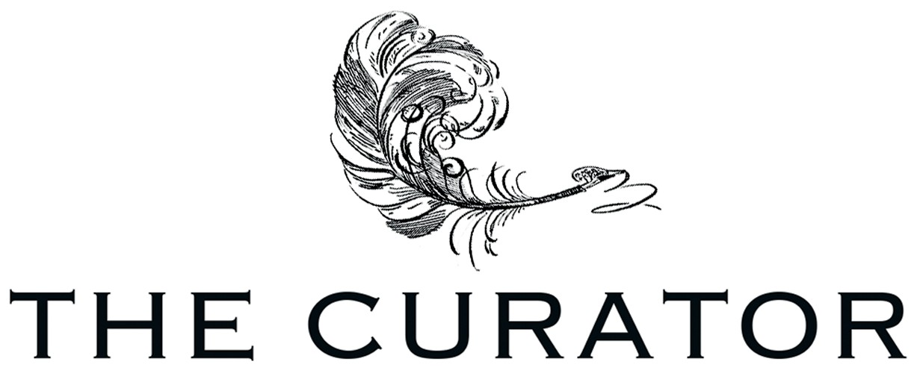
If you wish to withdraw from the contract, please complete this form and send it back to us along with returned rolls:

I/we (*) hereby give notice that I/we (*) withdraw from my/our (*) contract of sale of the following goods:

- Ordered number:

- Ordered on / received on:

- Reason for return:

- Quantity of rolls returned:

- Name:

- Address:

- Signature:

Return Address:

THE CURATOR, RAVENSWOOD 95, STATION ROAD, MARPLE, CHESHIRE SK6 6NY UK | +44 (0)7704 663423

